**ADVANCED DIGITAL SIGNAL PROCESSING**

**NOVEL ALGORITHM IMAGE THRESHOLDING USING NON-PARAMETRIC FISHER INFORMATION**

Santhosh Nagendran

8272767

**BRIEFING**

The Fisher information (FI) measure is an important concept in statistical estimation theory and information theory. However, it has received relatively little consideration in image processing. In this paper, a novel algorithm is developed based on the nonparametric measure. The proposed algorithm determines the optimal threshold based on the FI measure by maximizing the measure of the separability of the resultant classes over all of the gray levels. The algorithm is compared with several classic thresholding methods on a variety of images including some non-destructive testing (NDT) images and text document images, experimental results show the effectiveness of the new method.

**DESCRIPTION OF THE PAPER**

This paper is all about image thresholding, which means separation of sample image which

contains the actual object or the content and the background. And the thresholding is separation

of the content from the background which usually has more application in image processing.

Usually for the separation of the image there are so many algorithms available already which is

used based on the application and the accuracy of the result. But in this paper, we will be

discussing a new algorithm called Fisher Information.

**FISHER INFORMATION**

Fisher Information (FI) is an important concept in statistical estimation theory and information

theory. Novel algorithm is developed based on non-parametric FI measure.

**OBJECTIVE**

The aim is to make a binary image (object and background) by which all the pixels with grey level

higher than the determined threshold is classified as object and rest pixels are assigned to

background or vice versa.

**DESCRIPTION OF FI**

This FI based thresholding considers an image histogram to be a probability distribution and then

selects an optimal thresholding value that yields maximum fisher information (FI).

**FISHER INFORMATION THERSHOLDING**

The probability of gray level in the image is defined as,

P = n/N

Suppose that the pixel in the image are divided into two classes A and B by a gray level cutoff t. A is set of pixels with levels [0,1,…….,t], and the remaining pixels belong to B. A and B usually corresponds to the object class and the background class, or vice versa.

* Pi = ni./N;
* w1 = sum (Pi);
* w2 = 1 - w1;
* Ia = 1. /w1. * (sum ((((Pi+1) - Pi). ^2). /Pi));
* Ib = 1. /w2. * (sum ((((Pi+1) - Pi). ^2). /Pi));
* It = (w1. * Ia) + ((1-w1). * Ib);

tOpt = angle(max(((w1.*Ia) + ((1-w1).*Ib))));

Recently Abo-Eleneen and Abdel-Azim [37, 38], proposed FI-based approach to image thresholding, to extend Kittler and Illingworth's MET method and to developed a criterion that employs the combination between the FI measure and the intensity contrast to segment a normal MRI brain images and on a glioma MRI brain images respectively.

**ALGORITHM**

The proposed algorithm is a simple and effective thresholding method. This technique defines a new criterion that is based on the FI corresponding to two thresholded classes and determines the optimal threshold by maximizing the criterion. The following steps describe the proposed algorithm for image segmentation:

* Let *max=0 be* the optimal threshold, and let *max* be the maximum value of the objective function. I
* For t *=1* to Maximum of gray intensities
* Compute the function o*bjective* value that corresponds to the gray level t

If I(t) > *max*,

Then *max* = I(t), Topt= t.

end

Take Topt as the optimal threshold for segmenting the image.

**EXPERIMENTAL TEST**

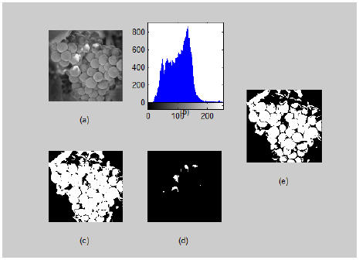

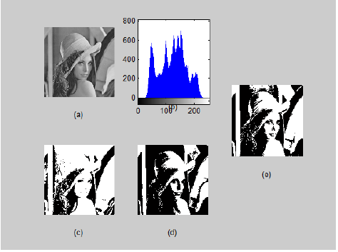

Thresholding results on the Grapes image: (a) original, (b) histogram, (c) Otsu’s method (t = 98), (d) Kapur (t =194), (e) the proposed method (t =111).

**TESTS OF FI**

Variety of images including non-destructive testing and text documentation images shown and

the result shows that the algorithm contained this technique was successfully separated.

In this section, a variety of real-world images is used for assessing the relative performance. Four sample images are used, namely Lena, Peppers, Grapes and Girl. These images are of more complex structures than the images in NDT and Text, which are not suitable for performing a quantitative measurement of the segmentation quality. The quality of the results is compared only by visual perception. Figures 3, 4, 5 and 6 displayed the segmentation results of the three methods. From these figures, it can be easily observed that the segmentation image based on the proposed method not only segments the target from the background, but also provides a thin and similar gray level segment very nicely. Moreover, it provides prominence to the interested regions.

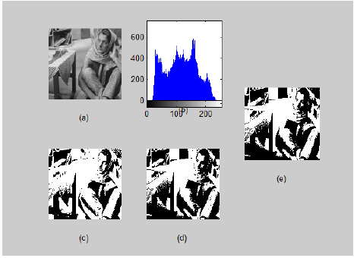

**CONCLUSION**

FI is a measure of the state of disorder of a system or phenomenon thus, it plays an important role in terms of physical theory. In this paper, we have developed a simple but effective method of image segmentation that employs the FI measure. This method assumes that there are two probability distributions; one distribution is for the object (class), and the other distribution is for the background class. The underlying idea of the proposed method is to maximize the FI within the object and the background classes. The proposed method has the following advantages:

* It is characterized by its nonparametric and unsupervised nature of threshold selection.
* The implementation of the method is very simple.
* The extension of the proposed method into multi-level thresholding and color images is an open problem for future exploration.